Edge Detection

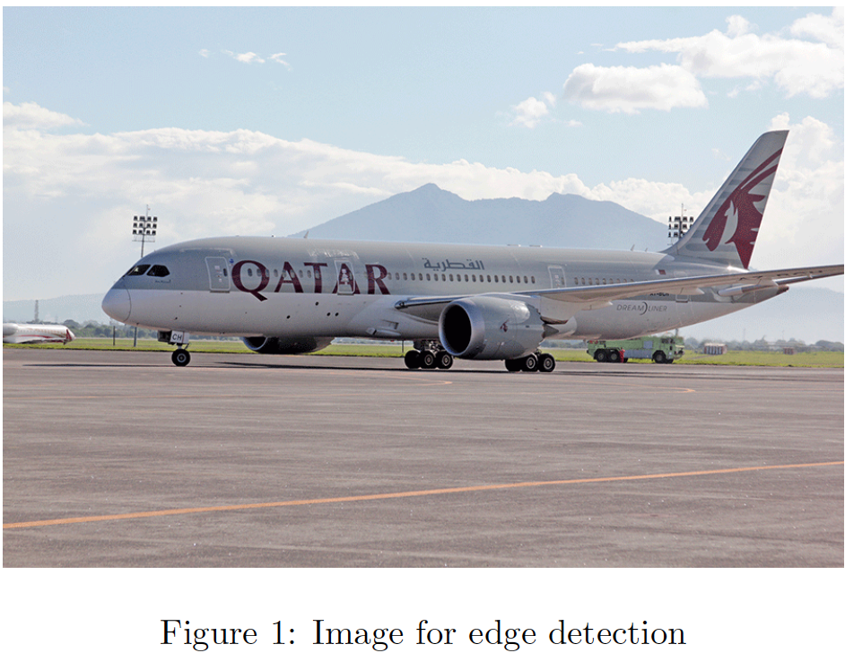

Write programs to detect edges in Fig. 1 (along both x and y directions) using Sobel operator.